**23. Megha Color Press Pvt. Ltd.**

**1. Summary**

**Megha Color Press Pvt. Ltd. (MCPPL)** have been continuously operating in printing business with the leadership of Mr. Arun Sapkota since 2002. It have been supplying quality printing in Nepal since 2013. We provide our services to many organizations such as publications, Education institutions and leading College. We have proven our ability to provide quality printed materials within expected delivery times. **MCPPL** have also been produce printed items with in critical and short lead times and challenging circumstance on demand of clients. Our commitment to clients has ensured that these requirements have been met. **MCPPL** is conveniently located near the geographical centre of Kathmandu Valley at Tokha Municipality - 5, Basundhara, near rind road. Our dedication, skill and love for the the company by teams of people who have worked with us in the past and those working here together today.

Now, we have modern sheet feed printing press and post press machines. Among them Heidelberg Speedmaster SM 74, Four Colour, Heidelberg Singal Colour two piceses, Horizon 4 Clamp Perfect Binding, Electromax Sigal Clam Perfect Binding, MBO Folding, Polar and Schneider Senator Guillotine, Stitching Machines, Lamination and Packing Machine etc.

Megha Color Press Pvt. Ltd. is the most preferred destination for printing materials. Our Book Printing Services are designed especially to meet the specific requirements of the clients. We offer ideal platform for printing activities.

Our trusted Clints are reputed book pulishers, educational institutes, hospitals, universities and colleges, NGOs, INGos and many more in Nepal.

**2. Highlights**

The highligts of the **MCPPL** are:

• A basic frame-work built from effective systems and production methodology. Competent, diligent and hard-working employees.

• Effective communication with clients and material suppliers.

• A culture of partnership with our clients.

**3. Experience**

**MCPPL** have 16 year of experience in printing. Understanding many kinds of businesses helps us connect and create long standing relationships from different sectors such as publishers, colleges, and educational organizations.

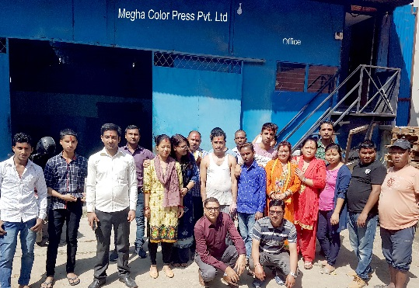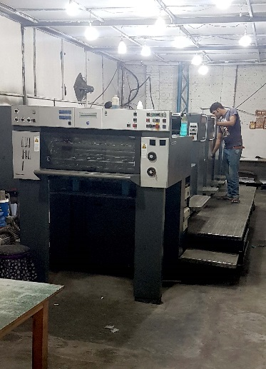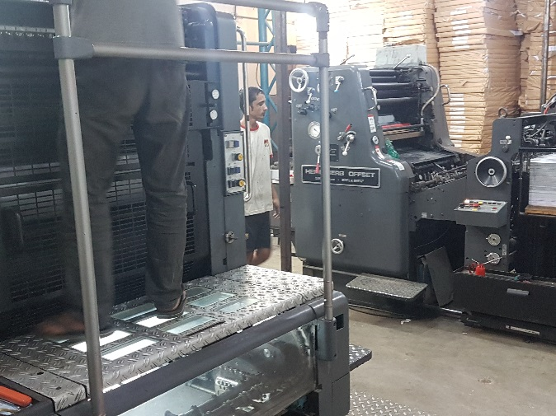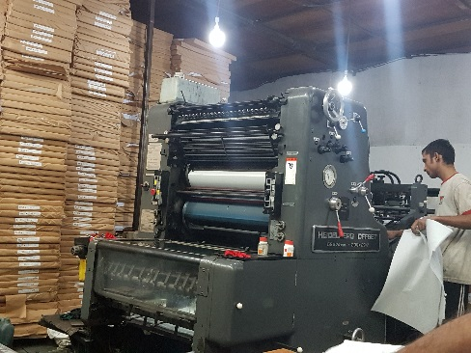 **4. Gallary**

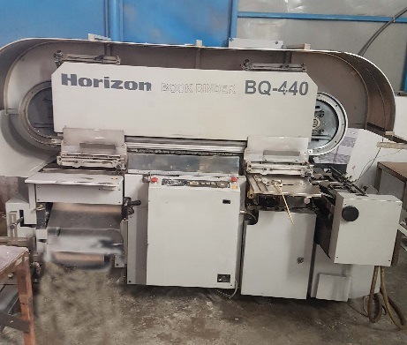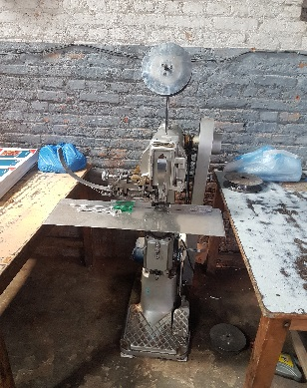

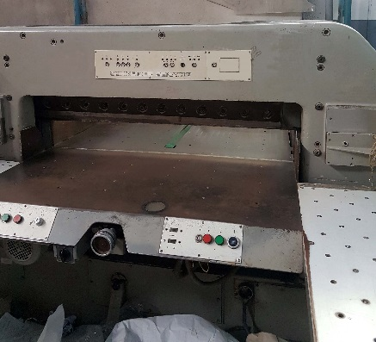

**5. Contact**

